



Signal Block Design Tool

User Manual

**Table of Contents**

Installation

Purpose

Main Screen

Create a New Track Segment

Import From file

Clear Database

Continue Previous Layout

Viewing Your Data

Data Grid

Track Segments

General

Track Layout

Help

Installation

To install the application, run the setup.exe application:

1. Double-Left click on setup.exe
2. 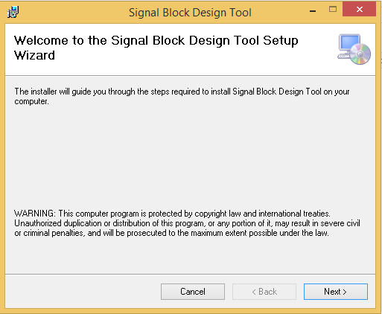
3. Click next
4. 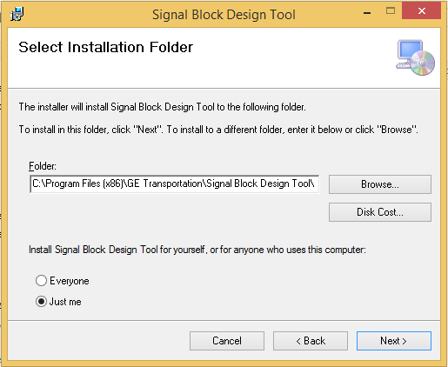
5. Click browse to set the installation path. The program creates a folder called GE Transportation.
6. Click the radio button to set who has rights on this program. The default is Just You, meaning the current user profile.
7. When finished left-click next.
8. 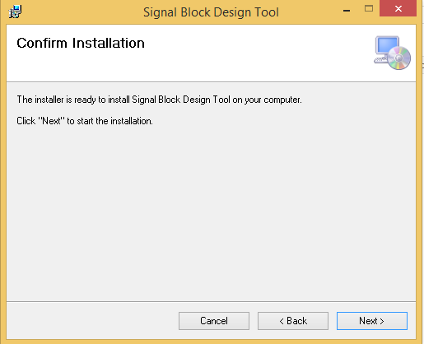
9. Left-click Next
10. 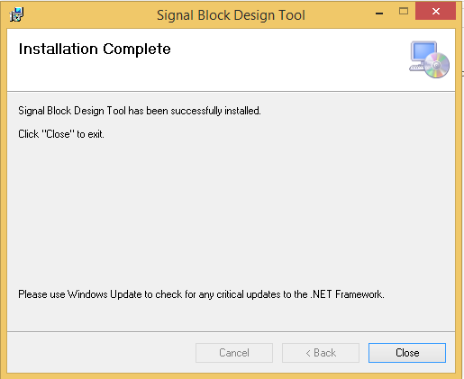
11. You are finished installing the program. There is a warning to check Windows Update for any critical .Net updates. .Net 3.5 is the minimum version this program is tested on. It is highly recommended to upgrade to at least .Net 3.5 or higher.
12. Left-Click Close.
13. On your desktop there will be an icon to run the program. Also in your start tray there is also the same icon to click to run the application.

Purpose

This program is designed to allow you to create a virtual track layout based on a series of parameters. The program will allow you to input parameters into a form and either store that information for later use or create a track and throw it away. The program will calculate a track segments safe braking distance as well as its runtime performance. You can view his data in a tabular view or by drawing the track and see the data segment by segment.

Main Screen

The main screen of the program is designed to allow the user quick access to all major features. All the main features are buttons in the form of tiles on the left side of the screen. Additional features can be found in the menu bar at along the top of the screen.

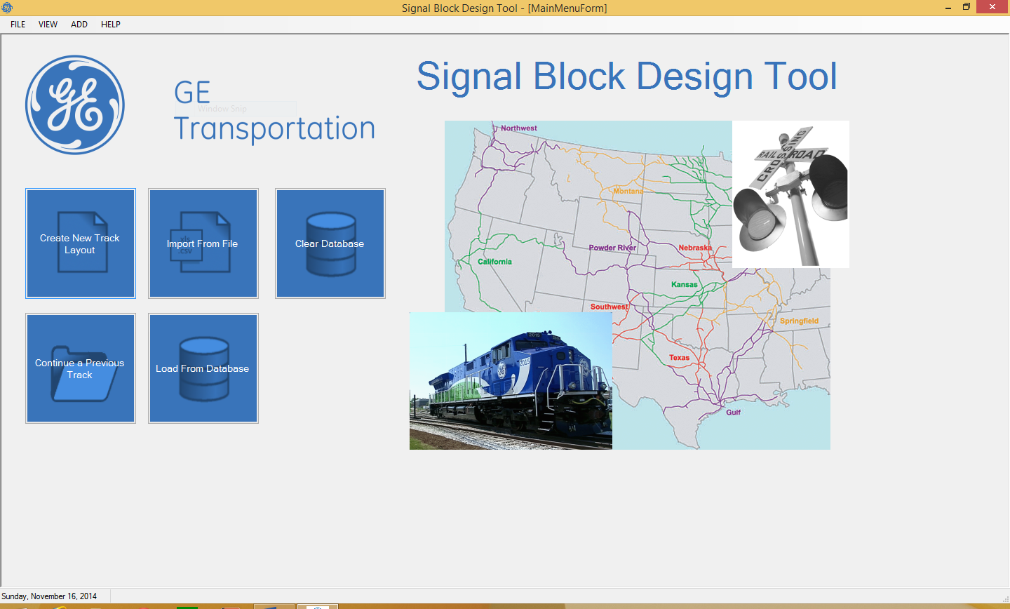

Create a new Track Segment

There are 3 ways to create a new track segment.

1. Left-click on create new Track Layout tile button
2. At the top of the screen at the menu-bar left-click on file-> new
3. At the top of the screen at the menu-bar left-click on add-> track segment

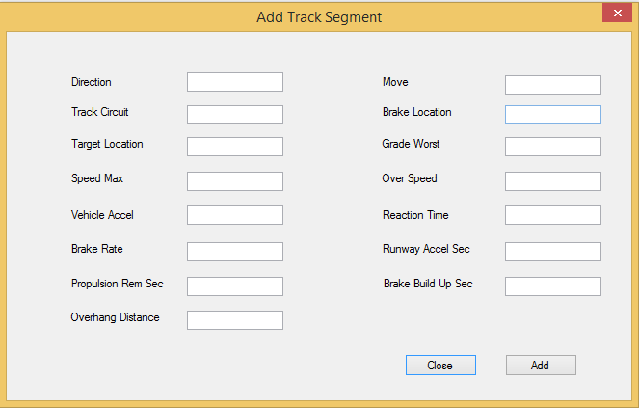

All of the fields must be entered to have a complete track segment.

The fields are the following in order from left to right:

1. Direction- the direction the train is moving. Examples of this is Northbound, Southbound, etc.
2. Track circuit- the track circuit the track segment belongs too. A track circuit is a section of track. A track segment is a subset of the track circuit. There is a one to many relationship between track segments and track circuits
3. Speed max- the max speed in miles per hour or kilometers per hour the train is expected to go along this track segment.
4. Vehicle accel- the rate of acceleration of the train
5. Brake rate- the rate at which the train brakes. Examples of this is 150 feet per second
6. Propulsion rem sec-
7. Overhang dist- the overhang distance.
8. Move- How the train is moving along the track. Examples of this is Normal or Reverse
9. Brake Location-
10. Grade worst- the maximum grade (incline or decline) the train can withstand
11. Over speed-
12. Reaction time-
13. Runway Accel sec-
14. Brake build up sec-

Import from a file

Import from a file is a fast way to load test data from a comma separated value file. Most computers come by default with the ability to read/write a CSV file. The load from a file tile button calls our Parser which takes the data in the csv file and imports it into the database. This data in the database is then rendered to the screen.

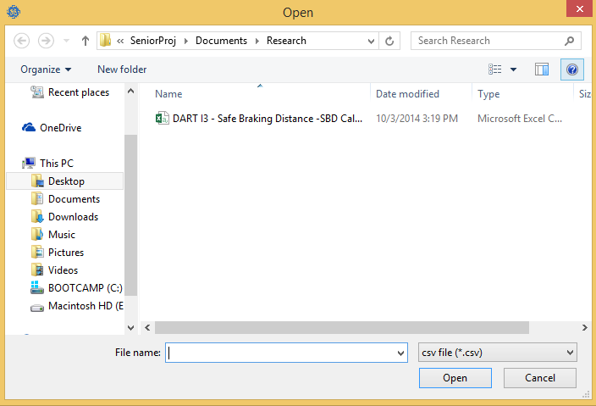

The import csv tile button opens up a dialog for you to look in your file system for a csv file to import.

Clear Database

The clear database tile button is a fast way to clear out all data in a database. This is good for when you have saved corrupted data or data that you no longer want. It is an all or nothing ordeal.

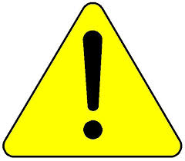 Once you delete the data, there is no backup unless you have saved the data to a file. See continue a previous track for more details.

Continue Previous Layout

When you save data, it is saved as an extensive Markup Language (XML) file. This can then be imported into the application. This is useful when you do not have an internet connection to connect to a remote database. When you left-click on the Continue Previous Tile button it will open a dialog that you can then look for a data file in XML to upload into the application.

An alternate way to load an XML file, in the menu bar left-click in file-> Load will also open a

The dialog box to load an XML file.

Load from Database

This is the preferred method of getting data from the application. To load from a database, left-click on the load database button.

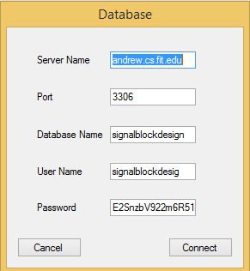

The fields are as follows:

1. Server name – the name of the remote server where the database is located. This is usually a web address in either Http://<website name>.com or Https://<website name>.com or an ip-address in the form of 192.168.0.01 as an example.
2. Port – the port to listen on. This is specific to the database. For MySQL as an example the default port is 3306. You can change this port to match your database connection.
3. The database name - This is the name of the database. This name was either created by you the user or a System Administrator.
4. Password – This is the password of the user of this database. If you do not know this information then consult your system administrator.

Connecting to a database requires a valid internet connection. Also, all of these connection fields must be filled in to connect.

Viewing your Data

On the menu bar at the top is the view tab. The View tab is where you can see the analysis of your results. It has 2 main menus: A data grid view which shows your data in a tabular form and a track layout view that shows you a visual representation of your train track layout.

Data Grid

The Data Grid view has 2 main tabs:

1. Calculations – This view shows you the Safe Braking Calculation as well as the braking distance available.
2. Track Segments – This view shows all of the data in the database. It is listed in rows and every row represents a single track segment. It will show either a range that you select or all track segments by default.

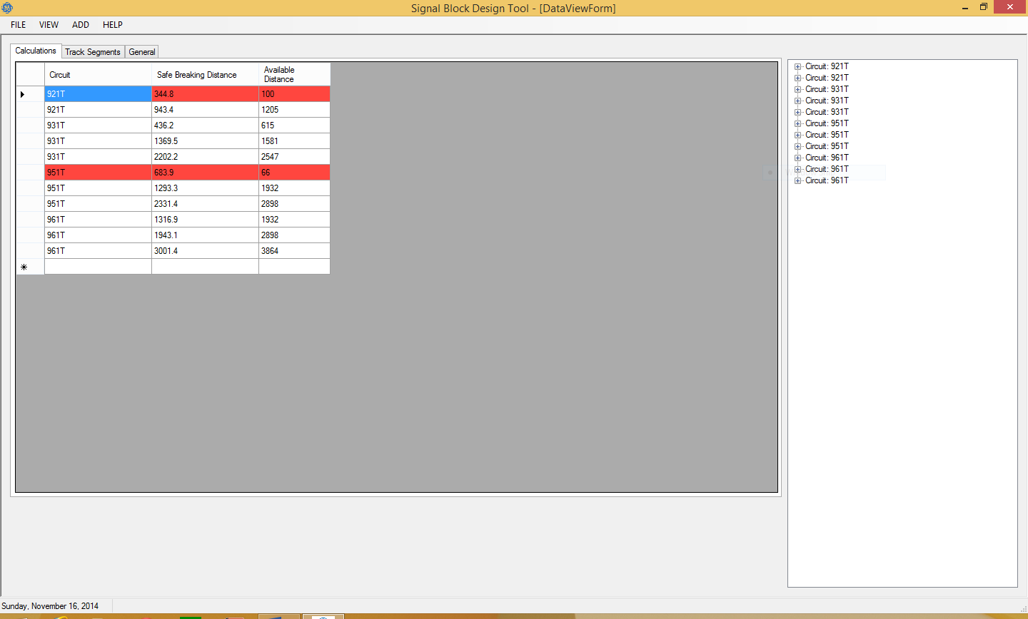

The calculation tab will display the following columns:

1. Circuit – The name of the track circuit that the track segment belongs to.
2. Safe Braking distance – The calculated sage braking distance based on the data.
3. Available Distance – The distance that the train has to stop in that track block.

If a row is colored red then it is an indication to the user that that particular track segment is unsafe. This is an indicator to a Track Engineer that the track segment needs to be redefined.

Track Segments

This view is shows all of the data that the user selects. It will show all track segments and is a visual representation of the csv file that was loaded into the program if you chose that option. Otherwise, it is a visual representation of the data in the database or XML file.

Again if there are highlighted rows that are Red then it is an indication to the user or Track Engineer that the track segment is unsafe.

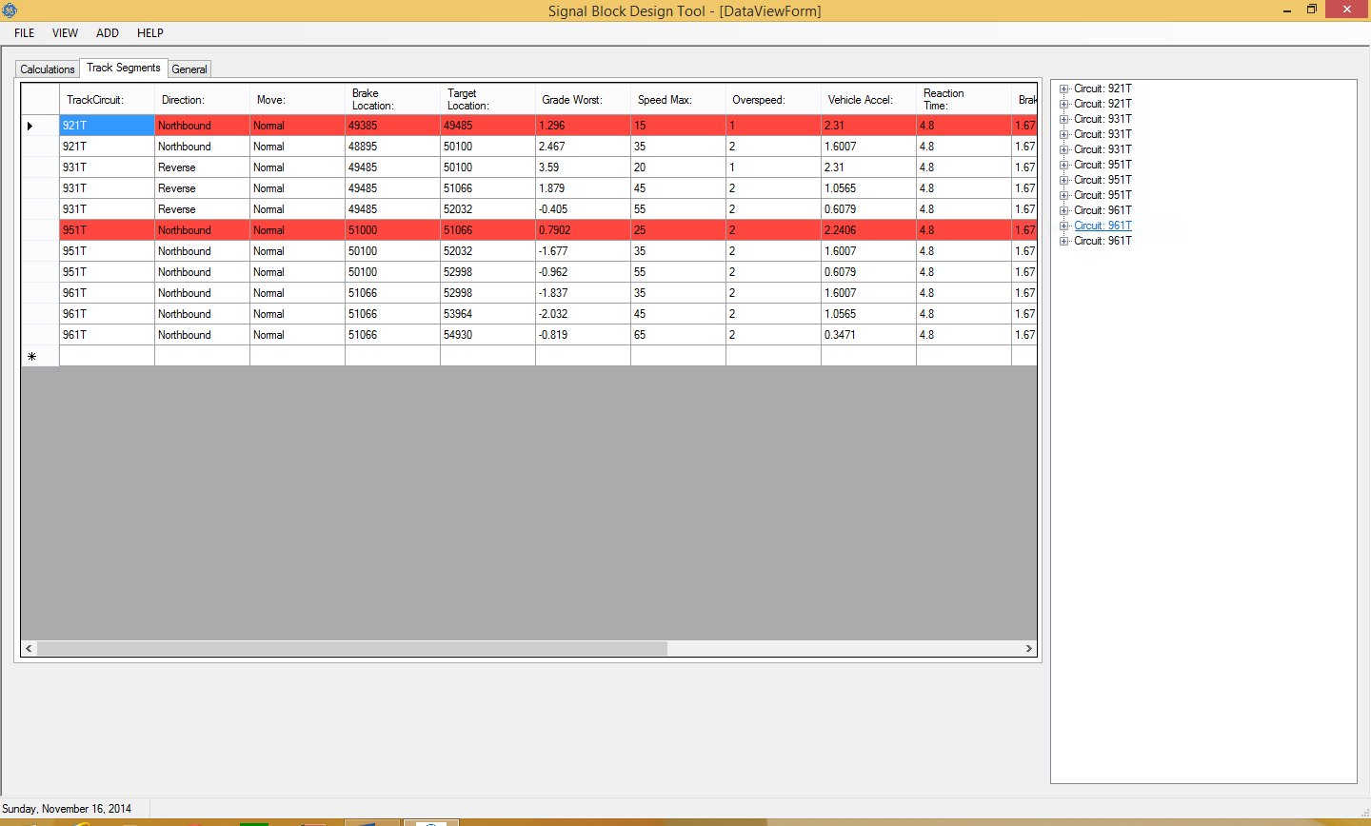

General

This tab is left blank for General Electric purposes. This will be filled in the next iteration when we hand the project over to GE. This tab was not the responsibility of the Florida Tech Team.

Track Layout

The Track Layout view is a visual representation of the track segments. It is a series of lines that represent the locations of the lines from the data. A blue line represents a track segment that is safe and a red line is an unsafe track condition. All unsafe track segments match the unsafe track conditions in the Data Grid View.

The Go to Track button will center the track. It finds the midpoint of the graphical representation of the track and centers it for you. This is used if you have a large track layout that may require scrolling to see all of the track.

You can zoom in and out with the use of your mouse scroll wheel.

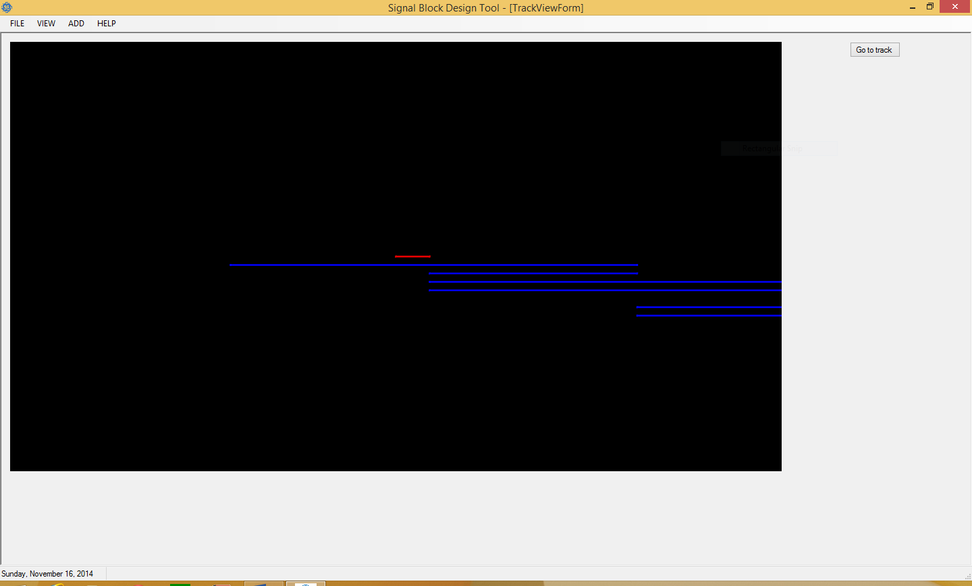

Help

The Help button will link you to our Github page where all source code and documentation is there. There you can post bugs to the bug report. This is a feature that will change when we turn this project over to General Electric to point to their experts.